SOP: Update your email in ESR
In this Standard Operating Procedure Guide, we will cover the process of updating your email address in ESR.

Step 1: Log into ESR
Log into ESR using your username and password or log in using your smartcard.

Step 2: Navigate to Personal Information
Now you are in the ESR Portal, you will need to navigate to the ‘My Personal Information’ tab. This can be found on the left hand side of your screen. Click on ‘My Personal Information’ and then in the drop down menu, click on ‘Personal Information.’
Please refer to the below screenshot if you are unsure:
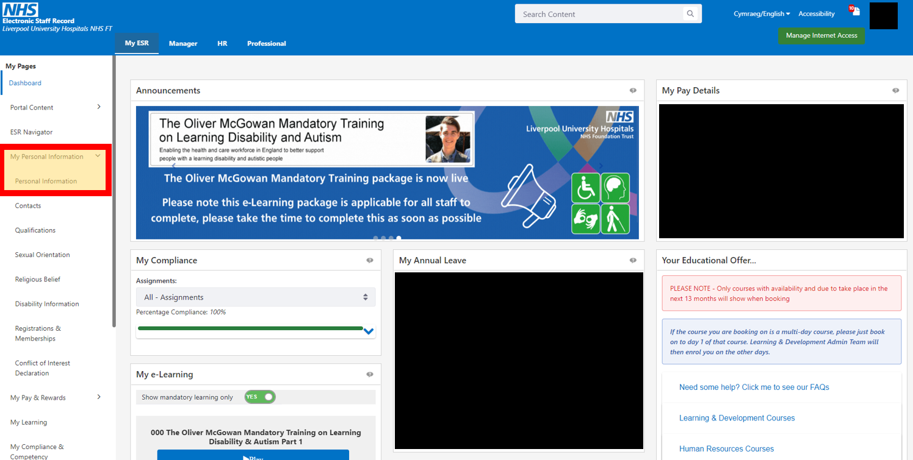

Step 3: Navigate to the Update Screen
Now you are in the Personal Information screen, you will need to navigate to the Phone Numbers & Personal Email screen to update your email address. To access the screen, click the Update button found on the right of the screen.
Please refer to the below screenshot if you are unsure:
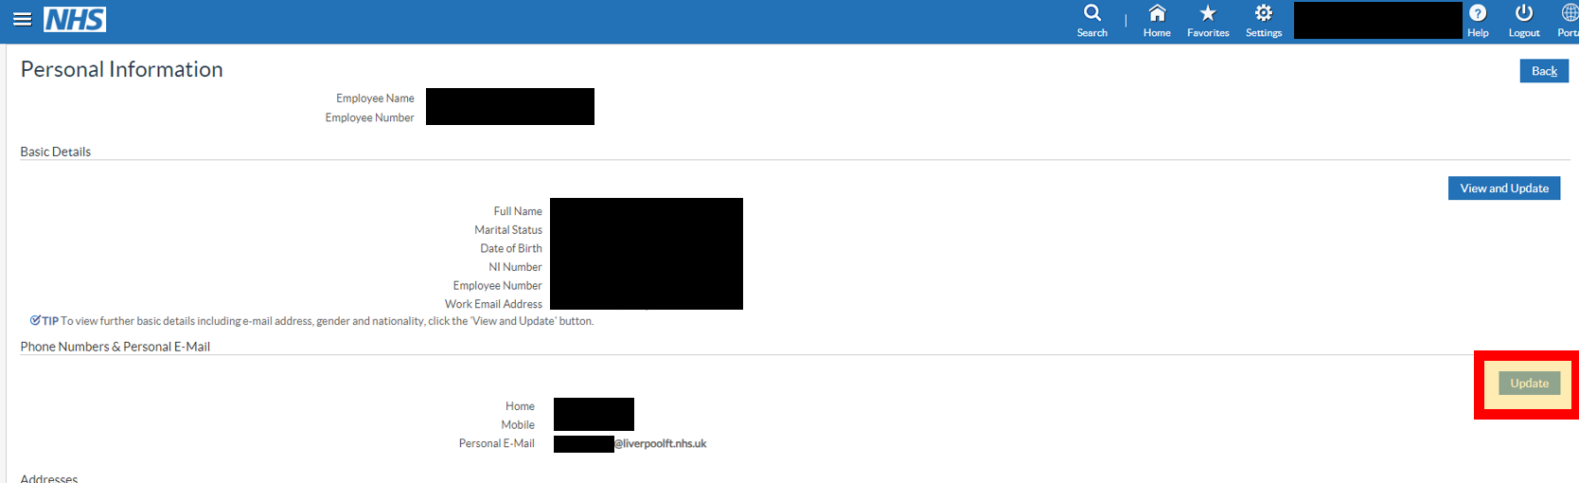

Step 4: Add in your new details.
Now you are in the Phone Numbers & Personal Email screen, you will need to add in your new email address.
You can do this one of two ways.
- Highlight the current email address, delete it and then replace it with your new email.
- Click the plus icon located on the left, click the drop down and select Person E-Mail, then input your email.
Once you have inputted the email, click the ‘Next’ button, found in the top right of the screen.
Please refer to the below screenshot if you are unsure:

Step 5: Submit Changes
Now you have entered your new email, you will need to review and submit the changes.
You will see the proposed changes at the centre of the screen. Once you have checked the changes are correct, you need to click the Submit button, found in the top or bottom right of the screen.
Please refer to the below screenshot if you are unsure:
